MGYOSZ-BOSMIP environmental protection conference

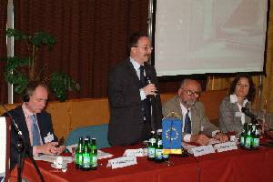 | The UNICE-BOSMIP program will last until December, 2004, which is trying to make the integration of the employers of the countries, who have just joined the European Union, easier. On the 26th of May, 2004, in the organization of the BOSMIP (Business Organizations as Single Market Integration Players, which is an institutional program controlled by the UNICE and supported by the European Committee) and MGYOSZ, an international environmental protection conference was held at the Hall of MGYOSZ in Budapest. István Wimmer, Secretary of MGYOSZ welcomed the participants.

In the previous years, especially regarding the accession to the EU, more and more attention has been drawn by the issues of the environmental protection – said Dr. István Debreczeny, Vice President of MGYOSZ Environmental Protection Committee, in his opening speech. We also pay attention to those questions, which basically would only arise in the future if we didn’t recognize them now and didn’t do everything, which can be possibly done. Connected to the accession, also derogation problems have appeared regarding the preparation and harmonization.

