Environmental protection in Northern Hungary
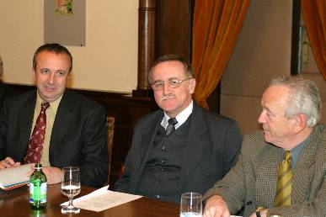 | {0><}0{>DrDD  Dr. Miklós Persányi, Minister of Environment Protection and Water Management had a discussion on 5th March 2004, at the Miskolc City Hall

with the leaders of the biggest member companies of the Employers and Industrialists’ Association of Northern Hungary (ÉGYSZ – member of MGYOSZ); Mr. Sándor Káli, Mayor of Miskolc and Mr. István Szentpéteri, Executive Director of ÉGYSZ, and Mr. István Pintér, Executive Manager of the Environmental Supervisory Body of North Hungary.<0} {0><}0{>The Minister agreed that a regional environmental program should be worked out on the basis of the national environmental program, and this program, as well as the appointment of the professional experts should be coordinated by the leaders of ÉGYSZ.<0} {0><}0{>Mr. István Szentpéteri, Executive Director emphasized that the regional environment program should directly focus on the special facilities of the region; and it is also important to point out the issues of the development of the environmental industry. He said that the environmental industry can become a leading factor in the region.<0}

