GUNDEL FORUM

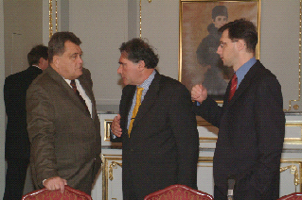 | The Confederation of Hungarian Employers and Industrialists (MGYOSZ) has held this year’s first Gundel Forum at the Gundel Restaurant on the 13th of January 2004. Mr. Mihály Varga, head of the Economic Cabinet of the Hungarian Civic Union, had been invited to the economic forum and has held a keynote lecture titled “Long-term perspectives of Hungary when the joining to the European Union is at hand”.

The points of MGYOSZ have been told by Mr. Gábor Széles, president of MGYOSZ. Mr. Mihály Varga, has also stressed that the participants of economy had been surprised by fact that the recession processes have lasted so long in the European Union. He saw the opportunity of development for the Hungarian economy in a predictable monetary policy and a trustworthy fiscal policy. Mr. Gábor Széles, stressing the importance of a more cautious law-preparation, emphasized that the pragmatic advices of MGYOSZ should be taken into consideration more compared to previous cases.

