Mr. István Stumpf in MGYOSZ

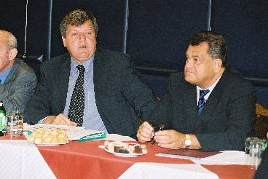 | Mr. István Stumpf - at the presidential meeting of MGYOSZ (Confederation of Hungarian Employers and Industrialists) On the 22nd of September, 2004, Mr. István Stumpf, ex-Minister of Chancellery, Principal of the Századvég Foundation and School attended the presidential meeting of the MGYOSZ.

The political scientist informally presented his own opinion regarding the internal political events of this autumn, the morals of the government crisis and the questions of the long-term and mid-term strategic projects of the upcoming time period. In his introduction, Mr. István Stumpf presented the activity of the Századvég Foundation; he mentioned his international experiences and made it clear that he is presenting his personal opinion to the participants of the presidential meeting. As per the ex-minister of chancellery, the democratic system based on the compromise, which was developed at the round-table conference in 1989, has got to the end of its capacity. Some elements of the model, that has been operating for 15 years, have become impossible to follow by today.

