The impacts of the European tax policies on Hungarian enterprises

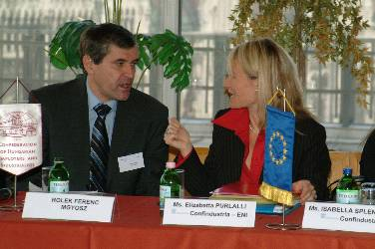 | CONFINDUSTRIA, BOSMIP and the National Association of Employers and Industrialists have organised this year their second conference on the 18th of October, in the House of Economic and Natural Sciences (Gazdaság- és Természettudományok Háza, Budapest, 5th district, Kossuth Lajos tér 6-8.), within the framework of the BOSMIP programme of UNICE. The objective of the programme - as Adrienn Lótos, the leader of the MGYOSZ office in Brussels informed the audience -, is to make the members of the industrialist associations of the new member states acquainted with the most essential parts of the Community law, and to share member state experiences regarding its practical implementation.

In addition, the BOSMIP programme develops the institutional capacity of the conjugate associations, so that they can provide their members with appropriate services. The participants of the conference were greeted by Ferenc Rolek, the deputy-chairman of MGYOSZ.

Dr. Gabriella Erdős, the leading consultant of Price-Waterhouse-Coopers gave a review of the most important tax issues concerning Hungarian enterprises, following the European Union joining. Financial and tax policy expert Ms. Barbara Streans-Balsing provided orientation on the current issues and perspectives of the European tax policies, and expounded the activities of UNICE concerning European Union tax regulations. Ms. Isabella Splendore, the tax expert of Confindustria analysed the developments of European tax policies from the point of view of her institution. Ms. Elisabetta Puralli, the consultant of ENI explicated how General Consumption Tax is operating in Europe, from the point of view of companies.

