House of the Economy and Sciences

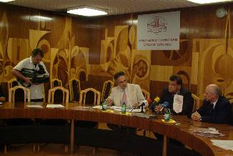 | The Confederation of the Hungarian Employers and Industrialists and the Federation of Technical and Scientific Societies have established the House of the Economy and Sciences. (Budapest, Kossuth Lajos tér 6-8.) The building on the bank of the Danube between the Hungarian Academy of Sciences and the House of Parliament provides space for a forum, which establishes contact between the participants of the economy, science, technical intellectuals and inventors. For this event, on the 20th of September, 2004 a press conference was held, where Mr. Gábor Széles, President of MGYOSZ and the MTESZ said the following:

˝István Széchenyi spent lots of time in the western countries, and based on the experiences he acquired there he decided to establish the Academy of Science in Hungary. During the past generations, it has been proved that the establishment of the Hungarian Academy of Sciences was an abiding idea. It is also the result of the operation of the Academy that Hungary has become a world leader in the area of basic researches. In the countries considered as old members of the European Union, there is a House of Economy almost everywhere, and a tendency has been developed here that shows that these institutes give support to the applied sciences, the cultivators of the nature and technical sciences, and the inventors and innovators are also respected partners in this field.

Estimating the demands, summarizing the experiences, the Hungarian House of the Economy and Sciences has to provide room for the co-operation between the corporate enterprises and the applied researches. In order to achieve the mid-term and long-term results, the tension has to be eased, which was developed between the basic and applied researches and the inventors. Our country’s economic power is not enough to be competitive in the field of the basic researches. We cannot afford to do basic researches parallel with other great research centres. However, on the other hand, it is an essential interest of the economy to apply the existing scientific achievements in practise as soon as possible. Therefore it is very important that the House of the Economy and Sciences shall be the forum, where the talent of economy, the science and innovator, and the inventor should strengthen each other. The MGYOSZ and the MTESZ wants to be the accelerator of these synergic processes.

Our aim to participate in the accomplishment of the country’s innovation strategy in an active and concentrated way also meets the government’s intent. The government has to support the transfer of the positions of the civil sphere from the central funds. By utilizing the existing assets we can improve the development of the applied research to a European level; and we can restore the value of the inventors’ activity. The key of our further improvement is the research strategy being adjusted to the demands of the economy. The House of the Economy and Sciences will provide a frame for this, which can increase the performance of all the participants.˝

Mr. Gábor Széles would like to have the MTESZ, as well to live a bustling life by the renewal of the ˝Duna-parti ház˝ (Danube-side house), which is adequate to the classical federation. By taking advantage of the opportunity, the organization of colourful programs has been started. Among these programs – the day before the orientations – the program series of the Club of the House of the Economy and Sciences began. It was called ˝Nights on Kossuth Square˝. On the 9th of September, the Hungarian Academy of Sciences, the Confederation of the Hungarian Employers and Industrialists, the Federation of the Technical and Scientific Societies, the National Office of Research and Technology and the Bay Zoltán Foundation for the History of Science and Technique organized a full-day event, called ˝Association for the successful Hungary˝, referred to the necessity of the co-operation of science, economy and legislation.

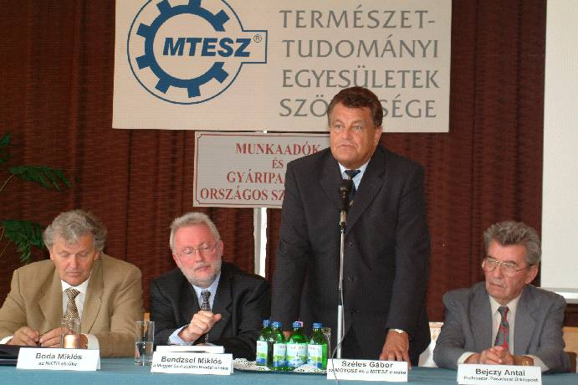

At the event, Mr. Gábor Széles, President of MGYOSZ and MTESZ made a lecture, called Our Technical-Economical creators and the innovative knowledge-economy.

