Environmental workshop

”The economic environmental management based on environmental information services” was the title of the workshop that was held by the Environmental Committee of MGYOSZ in the residential center of the Confederation, on 17 February 2004. Dr. Gábor Romhányi – Innotranz 2000 Kft. – gave a lecture. | 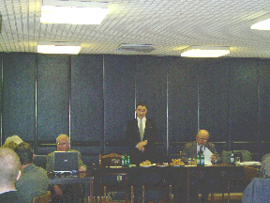
The workshop was started by a slide show presentation, introducing the theory and the method of the environmental registration of data and of the realization of the economic environmental management, and further on we will also introduce the Environmental Management System software. During his lecture Dr. Gábor Romhányi is going to pay a special attention to the issues of recycling, air and water management.

