Renewing cooperation

Round-table discussion on environmental protection

The Ministry of Environment and Water and the Confederation of Hungarian Employers and Industrialists have held a round-table discussion in the center of MGYOSZ. The event has been attended by dr. Miklós Persányi, Minister of Environment, Mr. Gábor Széles, President of MGYOSZ, Mr. István Orbán, General Vice-President of MGYOSZ, Mr. Miklós Galli, Vice-President of MGYOSZ and President of the Environmental Committee of the Confederation, the members of the Environmental Committee, | 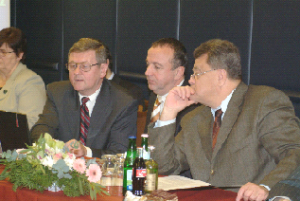
and experts from different areas of processing industry, commerce, energy industry, chemical industry and water management. The participants of the discussion have proposed a closer cooperation and have expressed their opinion that the members of the industry should have more influence in the preparation of decisions. For the enhancement of cooperation, dr. Miklós Persányi and Mr. Gábor Széles have signed an agreement on behalf of the Confederation of Hungarian Employers and Industrialists, and the Ministry of Environment and Water, respectively.

