A social discussion is needed

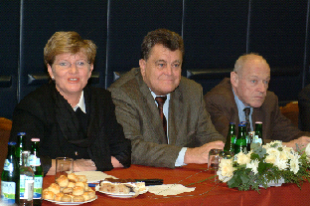 | Mrs. Katalin Szili, the president of the Hungarian Parliament, has participated the presidential meeting of the Confederation of Hungarian Employers and Industrialists, held on the 29th of January 2004. At the press conference following the meeting she has announced that she would propose the modification of the House Rules of Parliament in order to make it obligatory to hear the opinion of MGYOSZ in the Parliament before passing new laws that affect the Hungarian economy.
The President of Parliament will therefore initiate a four-party discussion. On the presidential meeting, Mr. Gábor Széles, the president of MGYOSZ has reminded the President of the Hungarian Parliament that during the recent months, there have been several cases when there had been no case study during the preparation of laws. Therefore the reconciliation at OÉT was less effective. The governmental side has not made any efficiency study, and they have belittled, ignored the calculations of the Employers’ side, made by the consultants of MGYOSZ. Mrs. Katalin Szili, president of the Hungarian Parliament, has agreed with the comments. She has also agreed that it was a serious mistake if the obligatory preliminary case study was missed. – It is not good if we talk to ourselves! A national discussion is necessary. – she said. The passing of the new constitution will be a reassuring solution, where the possibility of contribution to the debates can be institutionalized, even at plenary sessions.

L.G.

