Mr. Gábor Széles elected for the president of SZVT

The general assembly of deputies of the Scientific Society of Organization Management (SZVT), having a great past, has elected Mr. Gábor Széles for president on the 28th of January 2004 in Budapest. Out of the deputies having voting rights, 71 percent, i.e. 37 out of 53 were present, and have unanimously voted for Mr. Gábor Széles as the president, with one abstention. | 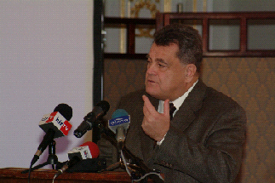

His predecessor, Mr. András Benedek had been leading SZVT for 8 years. He has become the state secretary of GYISM, and therefore has left his position of the civilian organization. We present an abbreviated and edited version of the presidential speech of Mr. Gábor Széles hereby. Mr. Gábor Széles, President of MGYOSZ, has drafted his ideas in his inaugural speech, held after having been elected. First he has told that when he had been called upon for accepting the nomination for the president of SZVT, he had been thinking 1/ how much advantage would it have for MGYOSZ, 2/ how much advantage would it have for SZVT and 3/ how much advantage would it have for the Hungarian economy if he were elected for the president of SZVT? And since he had found positive answers for all the three questions, ha had accepted the nomination.

