Austrian-Hungarian Professional Exchange of Experiences

The event of the professional exchange of experiences was held in Budapest, on the 1st of June, 2004 with the title of “Experiences of Successful Austrian Businesses after the Accession to the European Union”. The event was organized by the Confederation of Hungarian Employers and Industrialists (MGYOSZ), the Commercial Department of the Austrian Embassy, the Educational and Training Institute of the Austrian Economic Chamber (WIFI). Wimmer István, the secretary of MGYOSZ participated at the event | 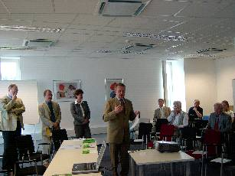
. The exchange of experiences was opened by Dr. Peter Rejtö, the commercial counsellor of the Commercial Department of the Austrian Embassy. The two speakers – the managers of two Austrian companies – after they had demonstrated the activities of their companies, spoke about their specific experiences. It is informative that according to the classification of the EU, the two companies fall in the category of small and medium size businesses, despite the fact that they are successfully operating all around Europe. One of the businesses is the REIWAG, which specialized for complex building operation, from cleaning, through maintenance to security activities. This company was represented by Thomas Dietterich, General Manager. The other speaker was Michael Hausler, General Manager, who controls the works of the Hausler Kft. This company deals with exploitation, elaboration and distribution of building blocks. Among the others, it does its production in Sóskút.

