InnoSME is your gateway to participate in RTD European projects

Objective
InnoSME intends to identify potentially innovative SMEs from the different ICT subsectors located in the new Member States, assess their capabilities, and improve their conditions in order to make them fitter for participation in RTD and Innovation projects of the FP7 and the CIP of the European Union

Target
Innovative SMEs of the ICT sector that will be the end-users and beneficiaries of the project activities

Internet
Platform
SMEs
Information
Services
Assessment
tools
Training
,
information
and advice
services

What we offer to the SMEs?
- A set of services (self diagnostic tools, training materials, personalised assessment) available to the SMEs in the InnoSME Web and in the stakeholder’s Web
- Advice about their innovation capabilities and potential and the set-up of improvement plans
- Workshops aiming to advice SMEs about their participation in FP7 & CIP, and helping them to search for partners
- A collaborative workspace to share information and best practices with other SMEs working in the same fields

Work process
The work process with SMEs will be as follow:
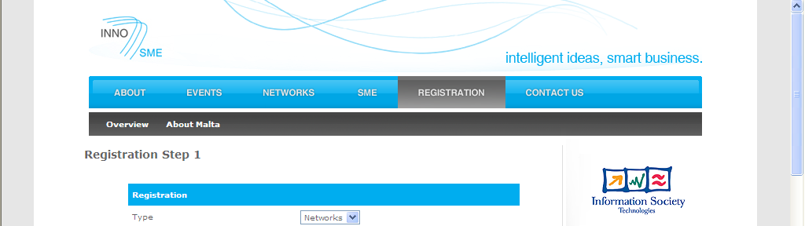
- SME access the InnoSME Web an fill-in a data-sheet, registration, obtaining their username and password
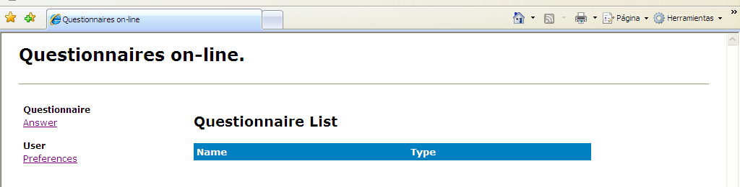
- SME can go inside the tools page and uses the self-diagnosis tool to know their innovation capabilities and potential
- SME receives a personalised advice about their position and can start an adapted training itinerary using the training modules
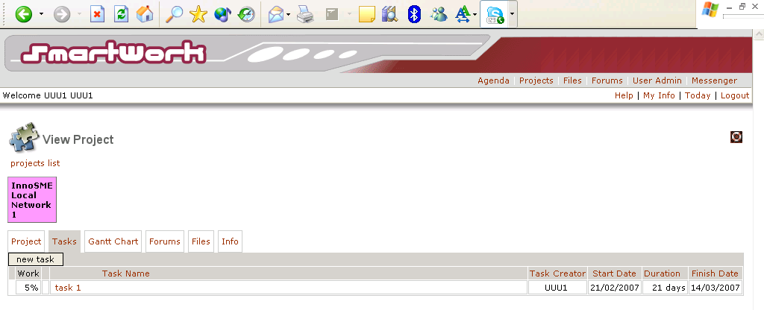
- SME can access the collaborative workspace Web and benchmark their position with other SMEs and share knowledge and ideas with the.
Which advantages for SMEs?
→ To know their innovation positioning and capabilities (self diagnosis)
→ To improve their innovation skills (personalised assessment and training)
→ To benchmark results and share best practices and experiences
→ To participate in FP7 & CIP of the European Commission (advice and matching)

